XWM – MySQL

TODO

Contents

Install – MySQL on Ubuntu 3

Create the virtual machine ‘xwm-mysql’ 3

Name and operating system 3

Memory size 3

Hard disk 4

Hard disk file type 4

Storage on physical hard disk 4

File location and size 5

Install Ubuntu 6

Download Ubuntu 6

Configure ‘xwm-mysql’ to boot from the installation image 7

Create a Virtual Box snapshot 9

Bridge the network connection 10

Install deja-dup and do a backup 11

Remote desktop using xRDP 13

Configure the firewall for RDP 13

Remote onto xwm-mysql 14

Install MySQL 15

Create a new user on ‘xwm-mysql’ 16

Login to MySQL as admin 16

Change the root password 17

Create a MySQL database 18

Create a MySQL table 19

Insert a row into a table 21

Create backups 22

MySQL backup (mysqldump) 22

mysqldump 22

Backup the mysqldump for ‘tufc’ on a network share 23

Share a Folder on the Network 23

MySQL remote connection 27

1 -Edit MySQL config file 27

Edit mysqld.cnf 27

Allow MySQL through the firewall 29

Remotely connect to MySQL on xwm-mysql 30

A few quick SQL tests - *CRUD* 31

Connect to MySQL server 31

SELECT 31

INSERT 32

UPDATE 32

DELETE 33

‘xwm-mysql’ is working 33

# Install – MySQL on Ubuntu

# Create the virtual machine ‘xwm-mysql’

To create a new Virtual Machine in Virtual Box

select: Machine > New

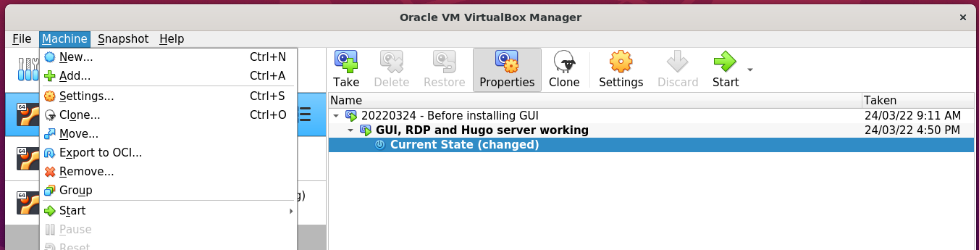

### Name and operating system

Name: xwm-mysql

Folder: /media/nath/4TB/XWM

Type: Linux

Version: Ubuntu (64-bit)

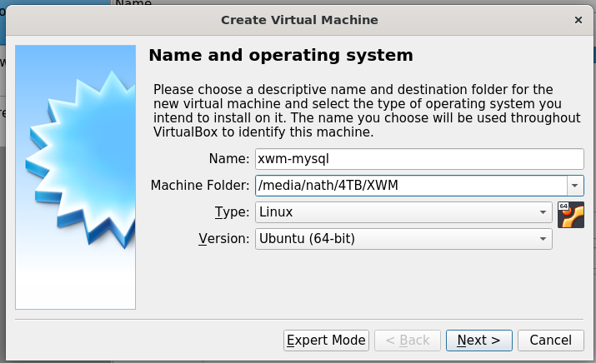

### Memory size

Select: 4096 MB

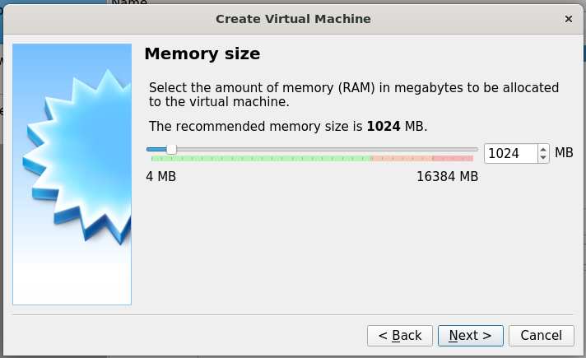

*Next, Hard disk …*

### Hard disk

Select: Create a hard disk now

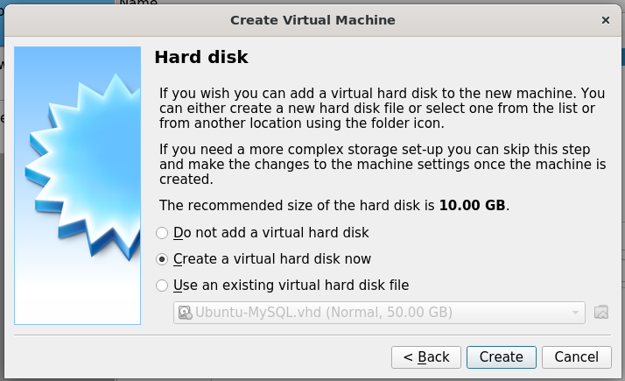

### Hard disk file type

Select: VHD (Virtual Hard Disk)

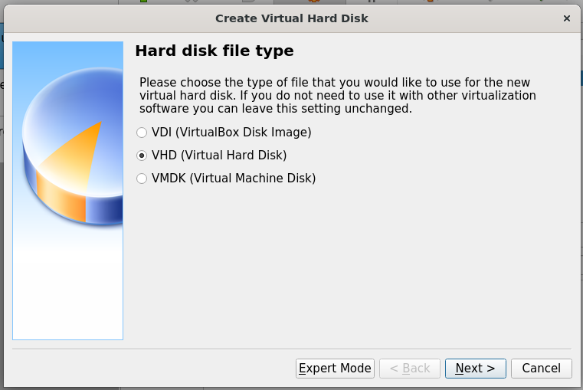

### Storage on physical hard disk

Select: Dynamically allocated

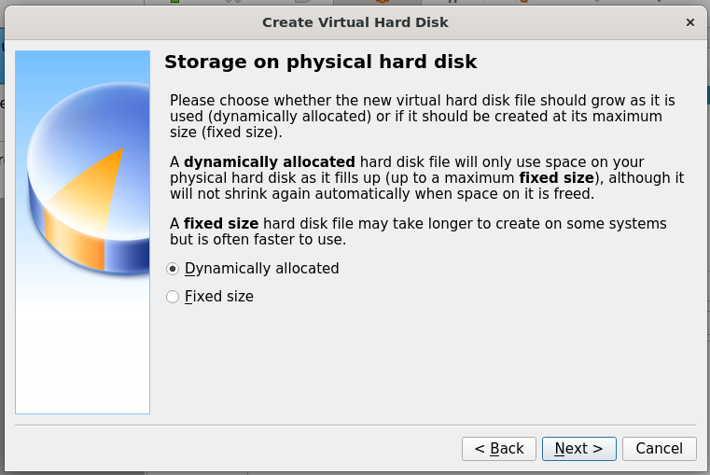

*Next, File location and size …*

### File location and size

Location: /media/nath/4TB/XWM/xwm-mysql/xwm-mysql.vhd

Size: 50 GB

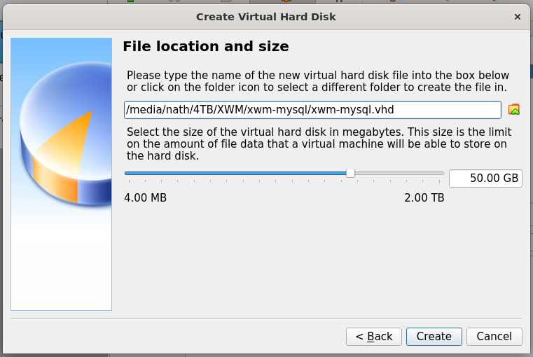

Click: Create *(above)*

The virtual machine xwm-mysql

is displayed in the left column Virtual Box.

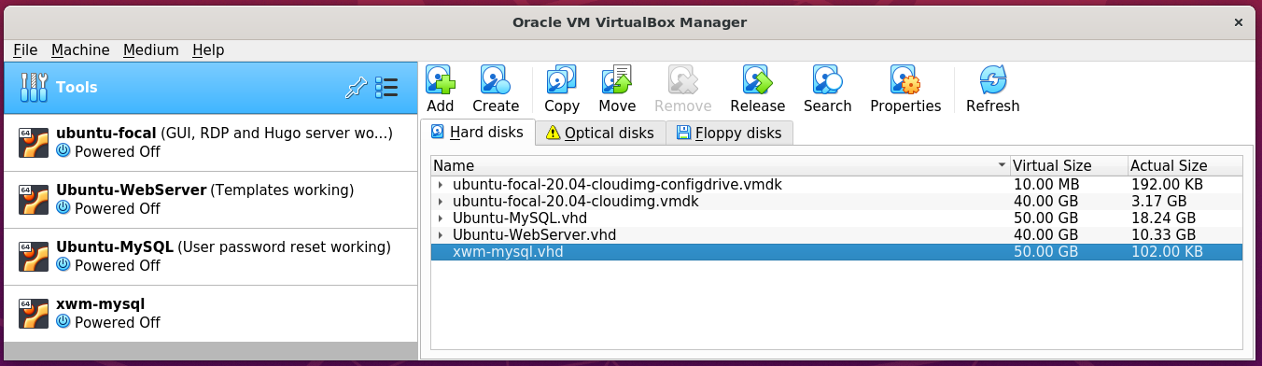

*Next, Install Ubuntu …*

# Install Ubuntu

### Download Ubuntu

Download the latest version of Ubuntu,

from: https://ubuntu.com/download/desktop

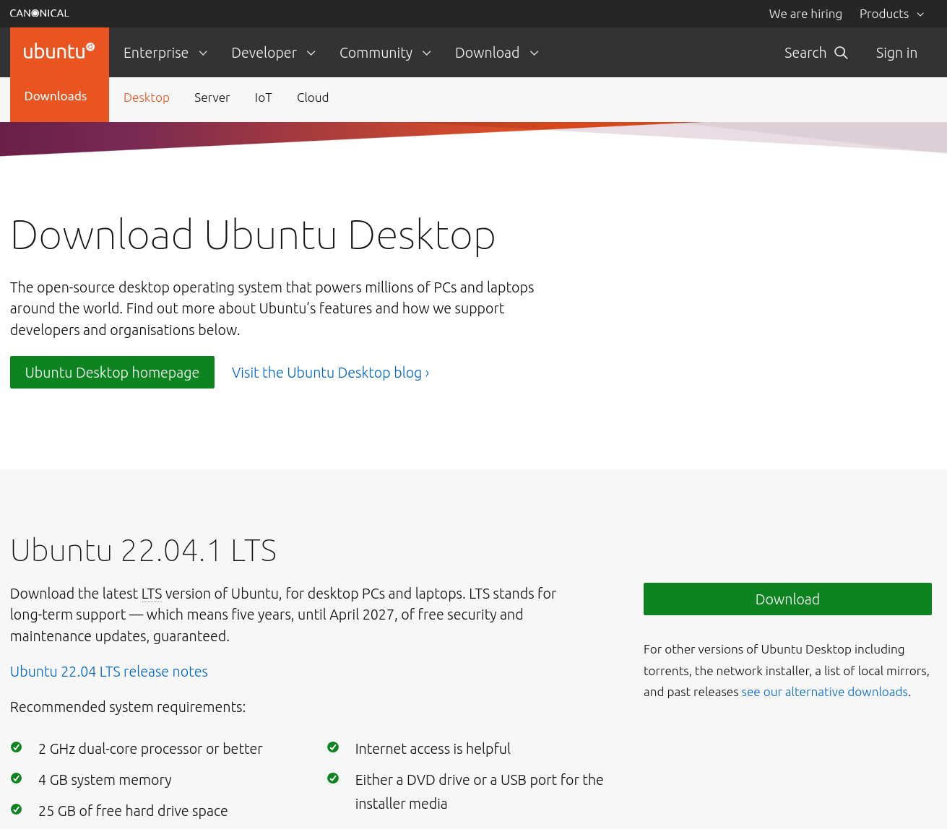

*Next, Configure* ***xwm-mysql*** *to boot from the installation image*

### Configure ‘xwm-mysql’ to boot from the installation image

Open Virtual Box on the host server Ubuntu-LAMP

In the left column

right click the virtual machine xwm-mysql

and select Settings

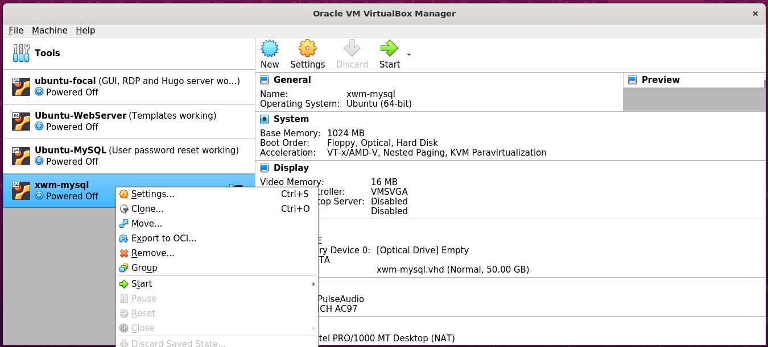

In the left column of Settings

select Storage

then in the middle panel

select Controller: IDE

on the right

select Choose a disk file

and select the downloaded Ubuntu installer

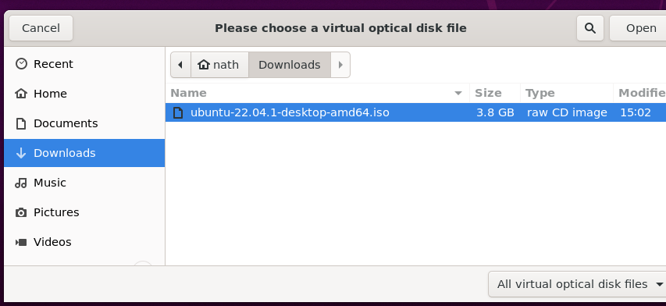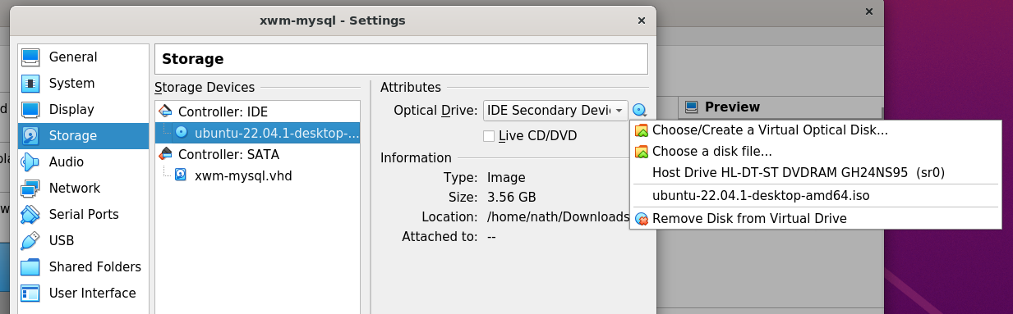

Now that installation iso has been selected

as the virtual machines CD

When the VMS starts-up it will install Ubuntu.

Start the virtual machine xwm-mysql

By clicking Start > Normal Start

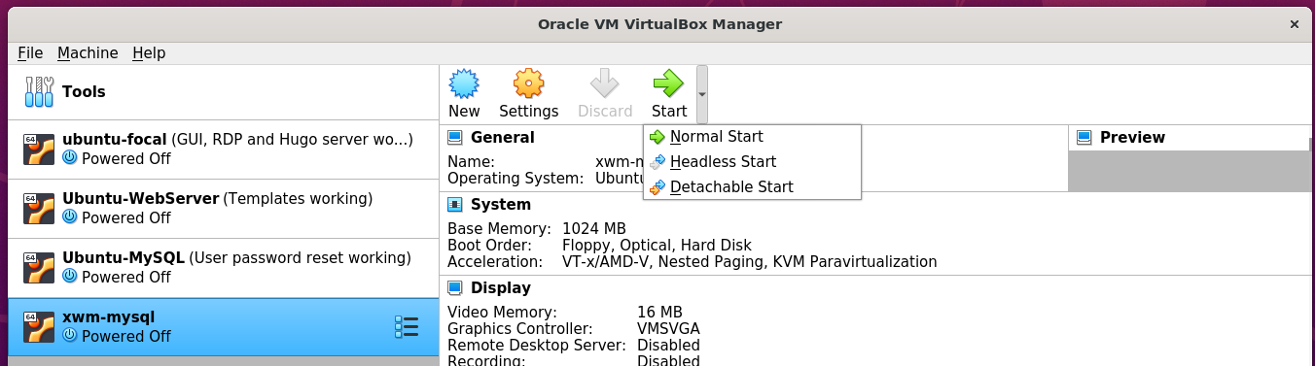

When the boot options are displayed

select: Try or install Ubuntu

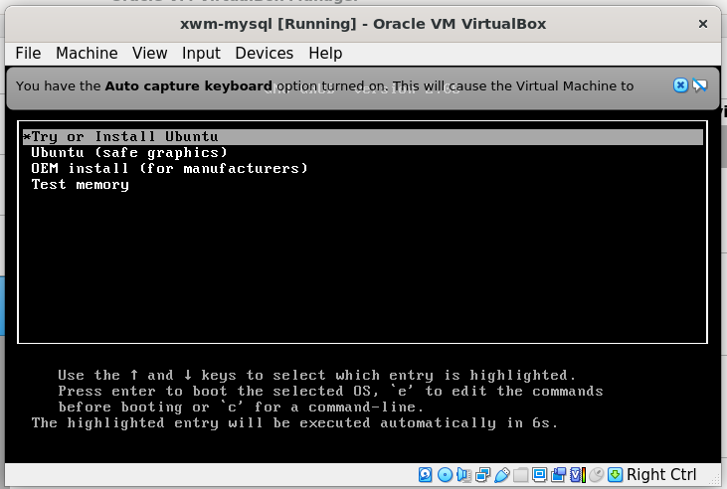

Follow the installation prompts to install Ubuntu

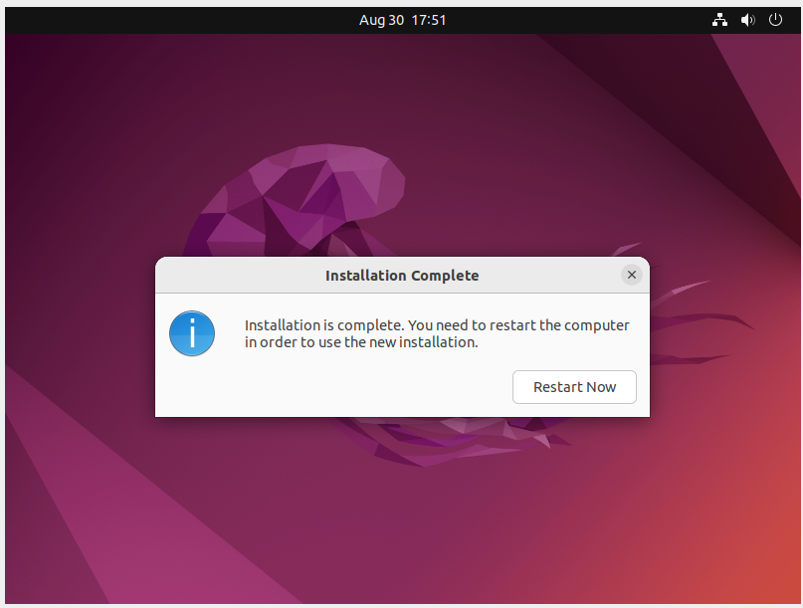

Shut down xwm-mysql

remove the installation iso

then restart the vm

to complete the installation.

*Next, create a snapshot …*

## Create a Virtual Box snapshot

Once the installation completes

shutdown the virtual machine

and create a snapshot of xwm-mysql

Create a snapshot

of the newly installed virtual machine xwm-mysql

In the left menu of Virtual Box

click xwm-mysql’s settings icon *(the waffle)*

and click Snapshots

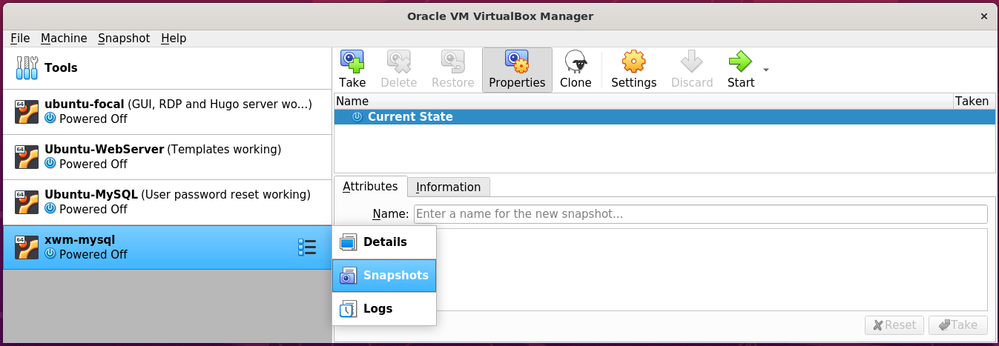

Then on the right, click the Take icon.

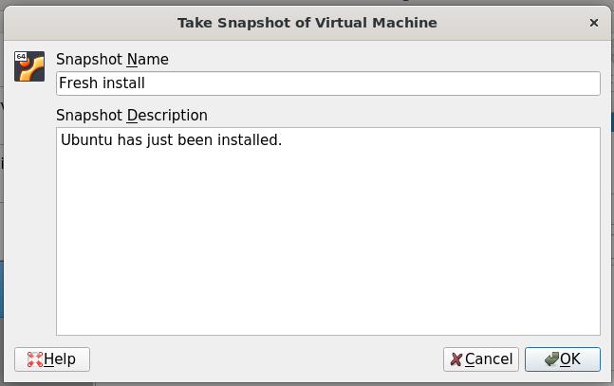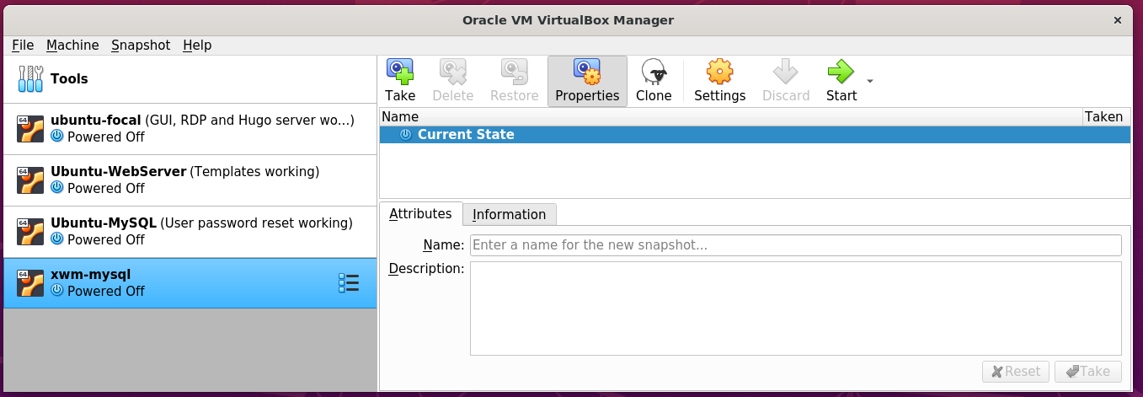

## Bridge the network connection

xwm-mysql is currently on it’s on virtual network.

To allow it to communicate with other devices on the network

right click xwm-mysql from Virtual Box’s left menu

and select settings

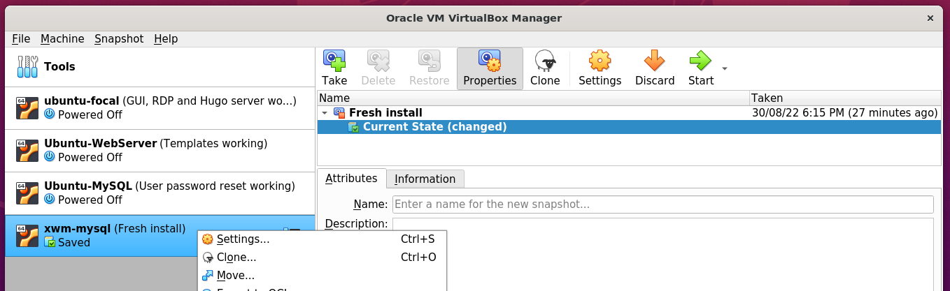

In Setting’s left menu

select Network

Set ‘Attached to’ to: Bridged-Adapter

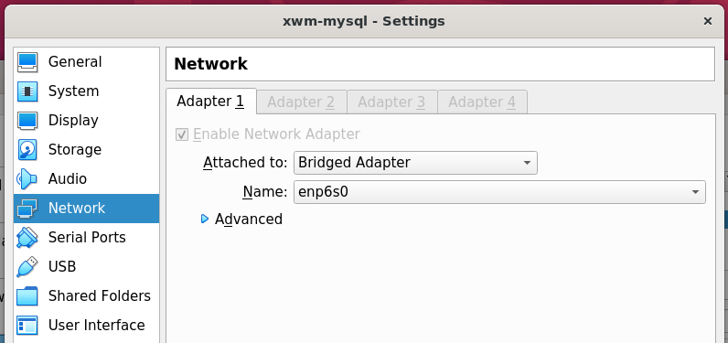

## Install deja-dup and do a backup

https://www.howtoinstall.me/ubuntu/18-04/deja-dup/

In terminal, run the following command:

sudo apt update

sudo apt install deja-dup

#### Example – Install deja dup

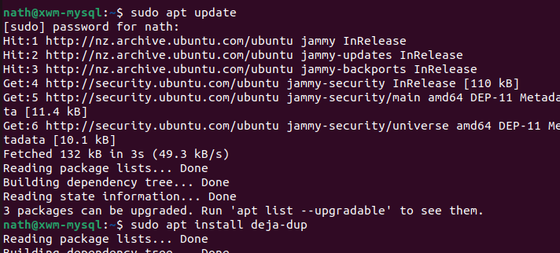

Once installed search for Backup

from Ubuntu’s Show Applications *(Start)* menu.

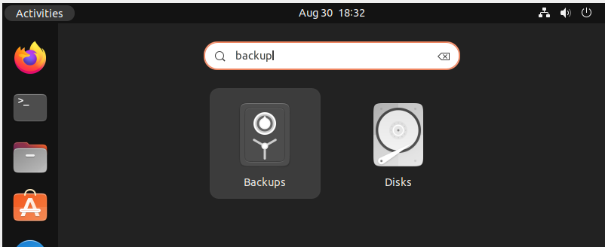

Click Create My First Backup

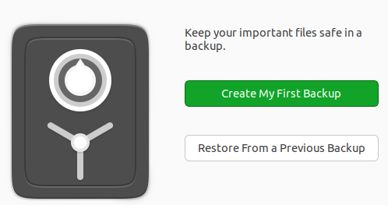

For the meantime, leave the default setting of my home folder: Home(nath)

as folders to be backed up.

In the future I will also need to back up the MySQL folders.

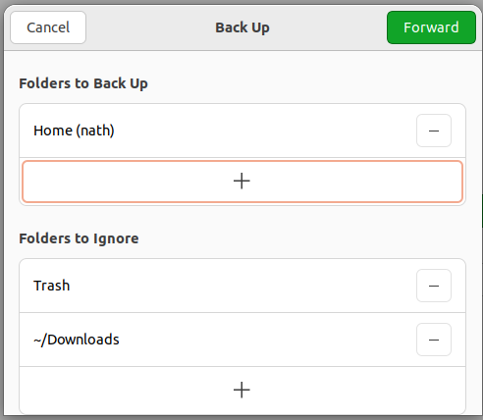

*Next, Select the storage location …*

Save backups to the USB drive

connected to the host machine Ubuntu-LAMP

Storage Location: Network Server

Network Location: smb://ubuntu-lamp.local/ vm_backups

Folder xwm-mysql

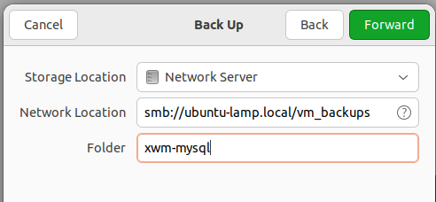

Authenticate as the user nath

on Ubuntu-LAMP

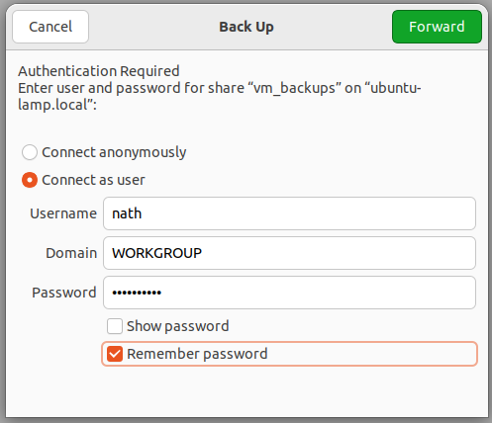

Create the password for the backup

for the virtual machine xwm-mysql

and select Remember password

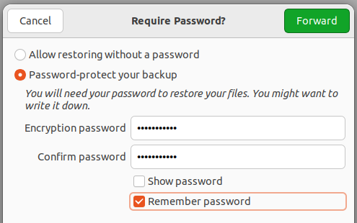

Once the backup completes

select Back up automatically

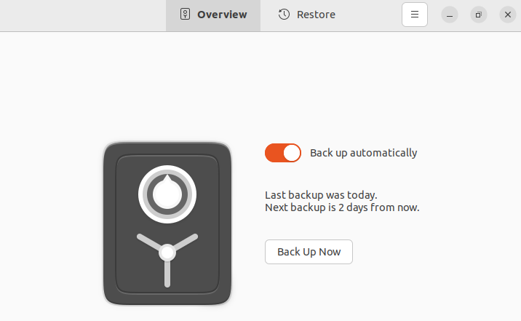

Take a snapshot of the virtual machine

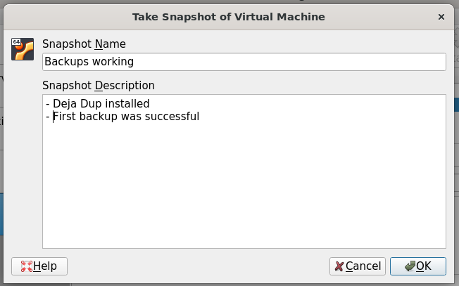

## Remote desktop using xRDP

Install xRDP *(and ‘snake oil’)*

then restart the server

sudo apt update

sudo apt -y install xrdp

sudo adduser xrdp ssl-cert

sudo systemctl restart xrdp

#### Example – install xRDP

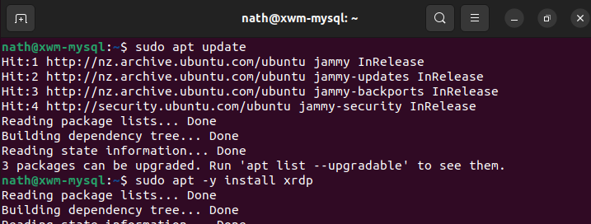

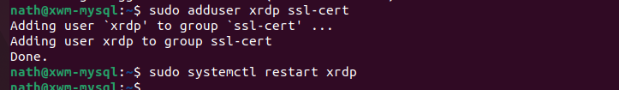

### Configure the firewall for RDP

To allow RDP connections, run the command:

sudo ufw allow 3389

sudo ufw enable

sudo ufw status

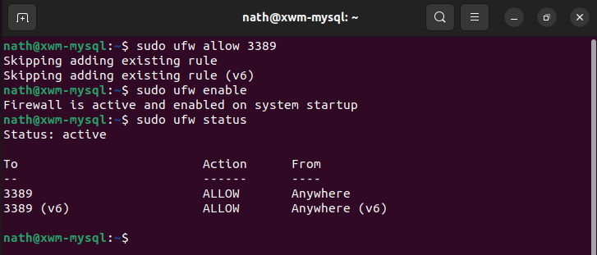

To allow the settings to refresh, restart xwm-mysql

*Next, Remote onto xwm-mysql …*

## Remote onto xwm-mysql

From Naths-Legion

Remote-desktop onto xwm-mysql

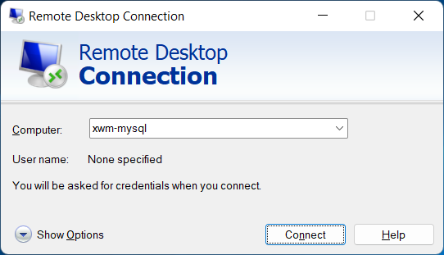

After accepting the connection certificate

xwm-mysql can be seen via remote desktop.

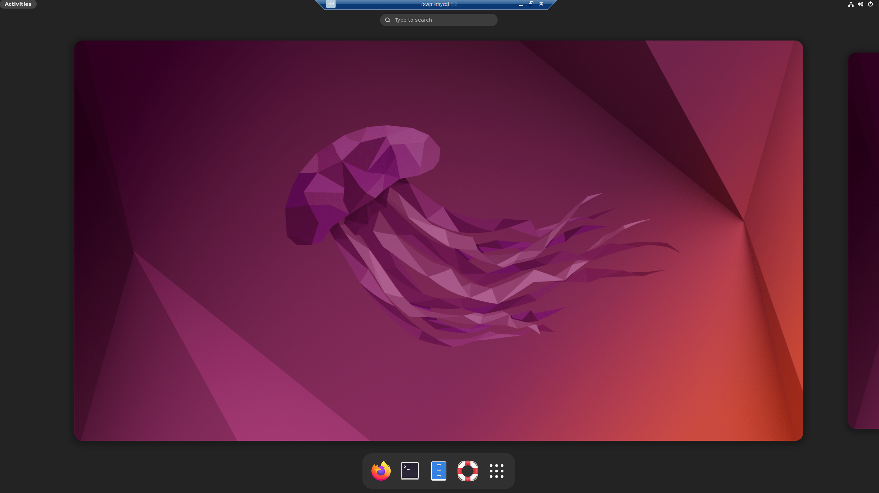

# Install MySQL

To install MySQL run the following command

sudo apt update

sudo apt install mysql-server

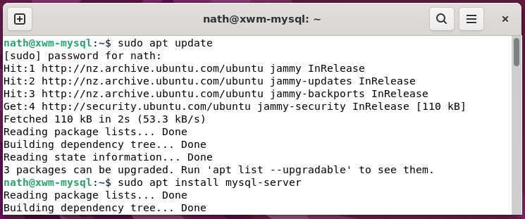

Check MySQL’s status, by running the command

sudo service mysql status

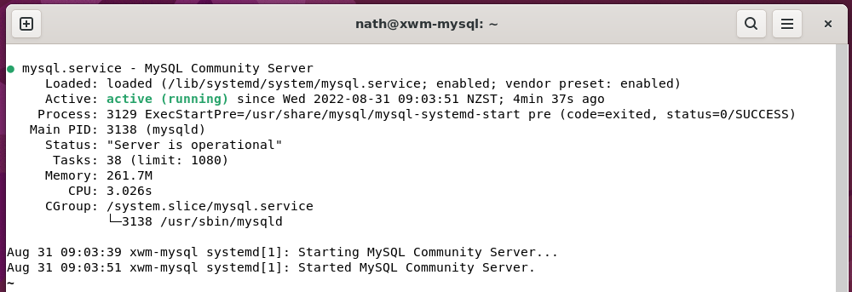

If the server is not running correctly

the following command will start it:

sudo service mysql restart

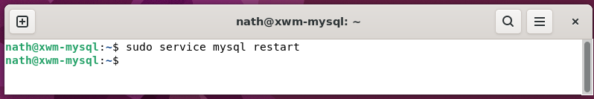

*Next, Create a MySQL user …*

## Create a new user on ‘xwm-mysql’

Open MySQL, by running the command

sudo mysql

#### Example – Run MySQL

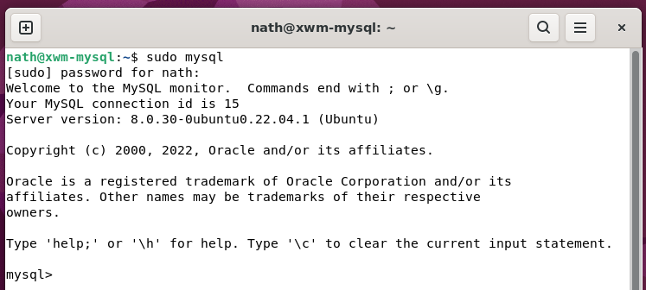

#### Example – Add a new user to MySQL

In MySQL, create the admin user

by running the command

CREATE USER '***username***'@'%' IDENTIFIED BY '***password***';

GRANT ALL PRIVILEGES ON *.* TO '***username***'@'%' WITH GRANT OPTION;

### Login to MySQL as admin

To login to MySQL as admin

run the following command

mysql -h localhost -u root -p

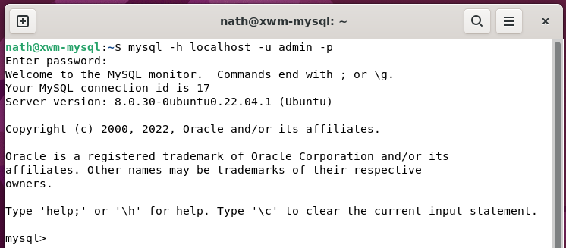

As everything is working up to this point

it’s great time to backup xwm-mysql

and take a Virtual Box snapshot.

#### Deja-Dup

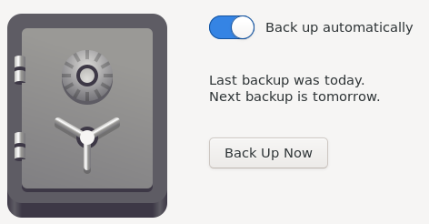

#### VirtualBox

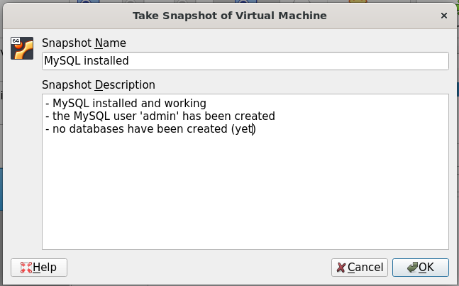

## Change the root password

By default, the MySQL user root

is included on all MySQL installations.

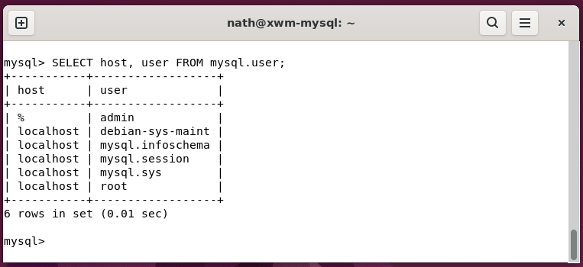

The password is often blank or ‘root’

which is a security risk.

Change the MySQL user root

default password, using the following command.

ALTER USER 'root'@'localhost' IDENTIFIED BY ***'new_password'***;

## Create a MySQL database

Open terminal and run app mysql

mysql -u *‘username’* -p

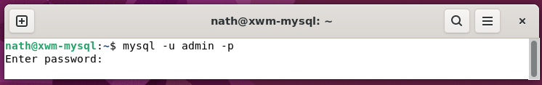

Create a database, for the application ‘The Ultimate Fitness Companion’ *(TUFC)*

#### Example – Create a database

Create the database tufc

CREATE DATABASE IF NOT EXISTS tufc;

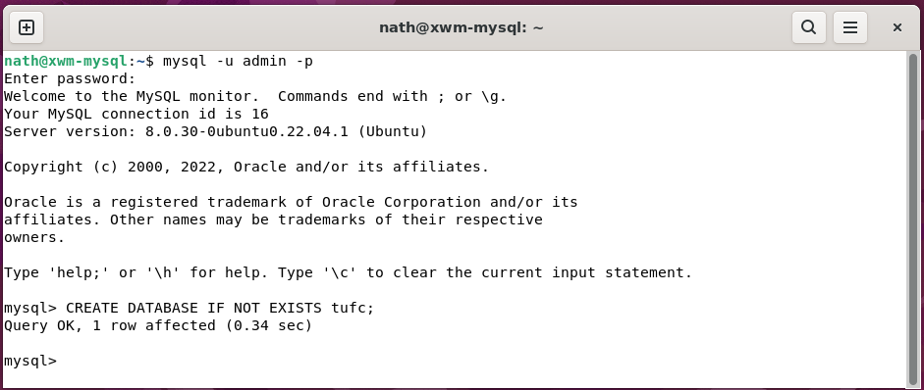

Now, select the database

so, its tables can be created.

USE tufc;

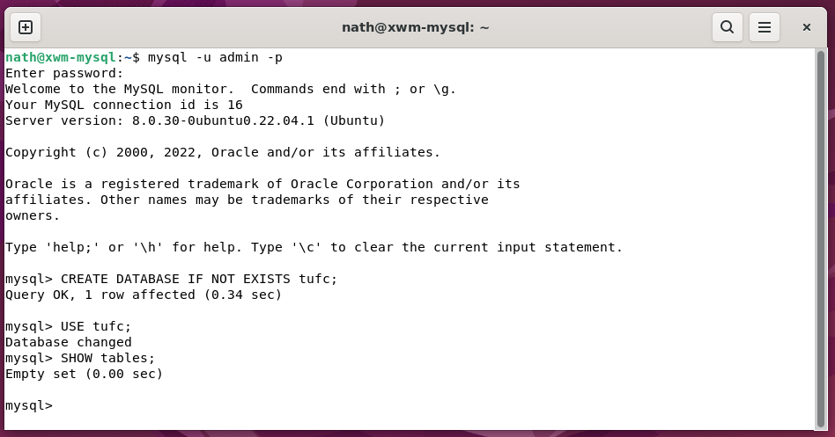

*Next, Create a TUFC table …*

## Create a MySQL table

Before adding a table to a database

it must be properly designed, using the following steps:

***1 – Choose the table name***

***2- Identify objects***

Objects: user

exercise

routine

***3 - Define and name a table for each object***

user: id

email

password

createDate

firstname

lastname

phoneMobile

phoneWork

phoneHome

number

street

city

zip

country

exercise: *to be determined*

routine: *to be determined*

***4 - Identify the attributes for each object***

***5 - Define and name columns for each attribute***

***6 - Identify the primary key***

***7 - Define default values***

***8 – Identify columns that require data***

#### Table - The fully designed table ‘User’

|  |  |  |  |  |  |
| --- | --- | --- | --- | --- | --- |
| **Table: User** |  |  |  |  |  |
| *Field* | *Type* | *Null* | *Key* | *Default* | *Extra* |
| userId | bigint | No | primary | NULL | serial *(bigint, unsigned, not null, auto_increment)* |
| email | varchar(255) | No |  | NULL |  |
| password | varchar(255) | Yes |  | NULL |  |
| createDate | datetime | No |  | NULL |  |
| firstname | varchar(255) | Yes |  | NULL |  |
| lastname | varchar(255) | Yes |  | NULL |  |
| phoneMobile | varchar(255) | Yes |  | NULL |  |
| phoneWork | varchar(255) | Yes |  | NULL |  |
| phoneHome | varchar(255) | Yes |  | NULL |  |
| number | varchar(255) | Yes |  | NULL |  |
| street | varchar(255) | Yes |  | NULL |  |
| city | varchar(255) | Yes |  | NULL |  |
| state | varchar(255) | Yes |  | NULL |  |
| zip | varchar(255) | Yes |  | NULL |  |
| country | varchar(255) | Yes |  | NULL |  |

*Next, Create the table ‘User’ in MySQL …*

To create the table User, use the command

CREATE TABLE();

#### Example - Create the table User

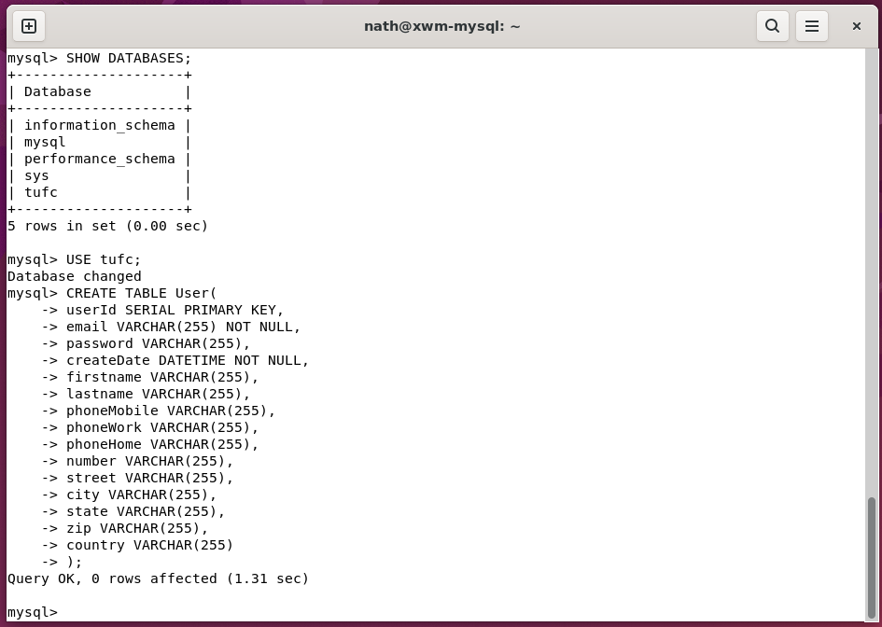

Once the table has been created, review the tables configuration

using the command

EXPLAIN

#### Example – Show a tables configuration

EXPLAIN User;

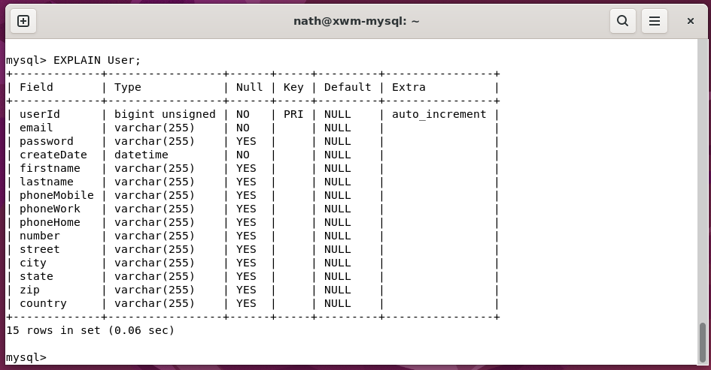

*Next, Insert a row into the table ‘User’ …*

## Insert a row into a table

The table Users

is located in the database tufc

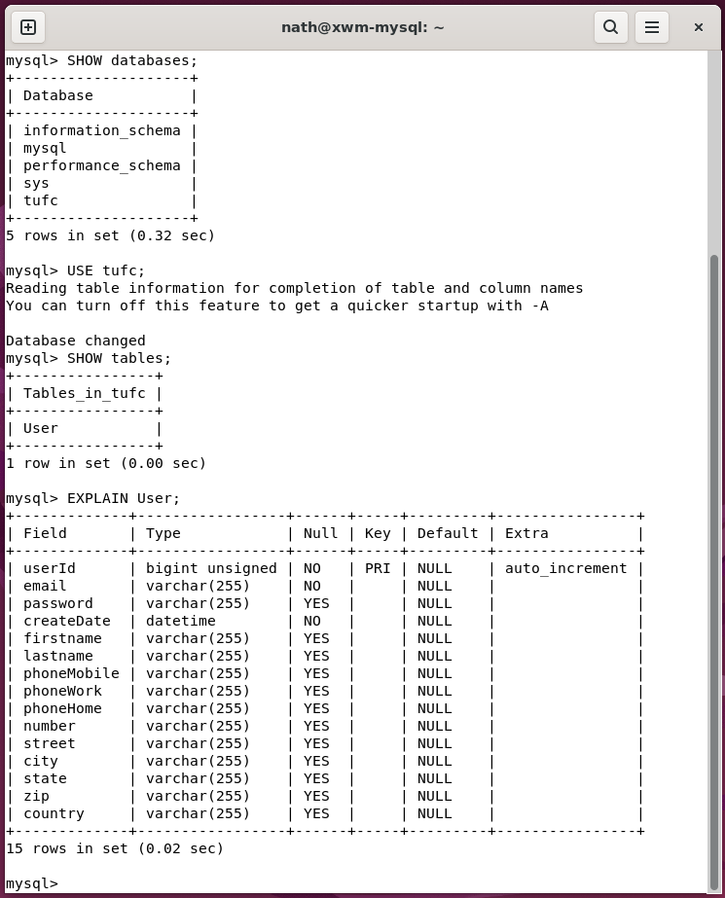

A User object can be inserted into to the table

using the command:

INSERT INTO table_name (column1, column2, column3, ...)  
VALUES (value1, value2, value3, ...);

I’m currently focused on creating XWM’s system structure

so, I won’t go overboard with data

when creating the first row.

However, I do need to include:

* email *(the user’s email address)*
* createDate *(the current time)*

as these cells are configured as NO NULL

The column userId is also set to NOT NULL

however, a value is not required

as it is set to auto increment.

#### Example – INSERT an object

INSERT INTO User (firstname, lastname, email, createDate)

VALUES ('Joe', 'Satriani', 'j.satrianin@mail.com', NOW());

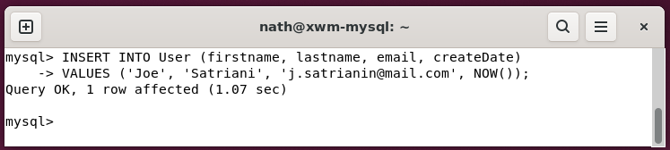

To confirm the new user has been added

to the table User, use the command

SELECT *

FROM table

#### Example – Show a tables content

SELECT *

FROM User;

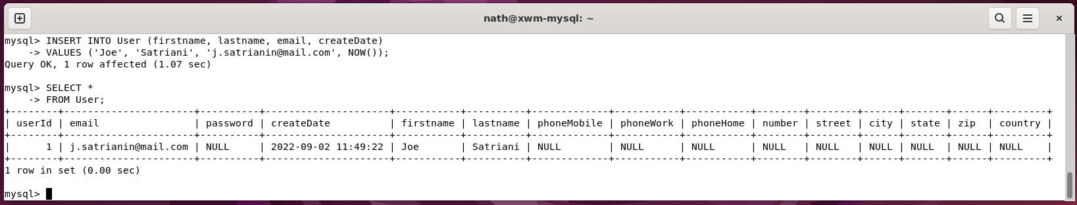

# Create backups

Now that

* Ubuntu and MySQL have been installed
* Remote desktop is working
* The database tufc and the table User have been created

It’s a great time to do backups, including

* a MySQL backup *(mysqldump)*
* an Ubuntu backup *(Deja Dup)*
* take a Virtual Box snapshot

## MySQL backup (mysqldump)

To back up MSQL databases, use the command

mysqldump can be used

Now that the table User has been created

in the database tufc

a MySQL database backup *(‘dump’)* can be created.

### mysqldump

The terminal command **mysqldump**

creates a text file backup of a database.

mysqldump --user=accountname --password=password databasename >path/backupfilename

#### Example – Backup the database ‘tufc’, using mysqldump

Save a backup of the database tufc.sql

to the folder /home/nath/mysql_backups *(***~** *is shorthand for /home/’user’)*

mysqldump -u admin -p tufc >~/mysql_backups/tufc.sql

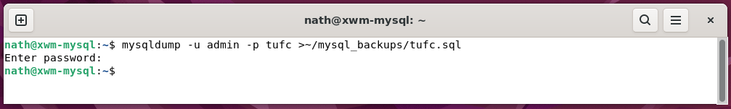

**Note:** Even though this command is run from terminal

-u ***‘username’*** is a MySQL account, not the Ubuntu username.

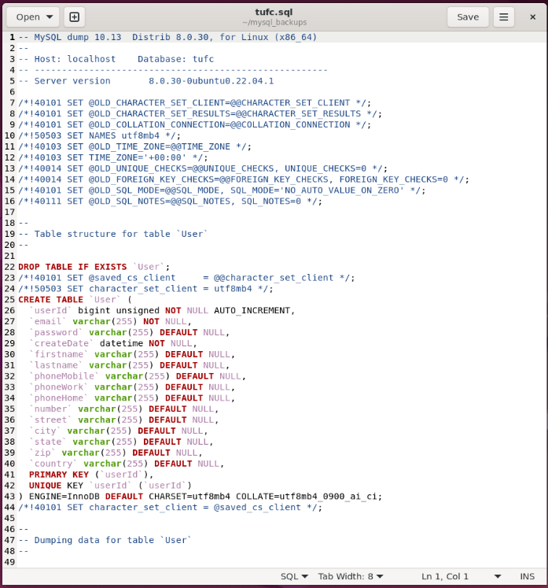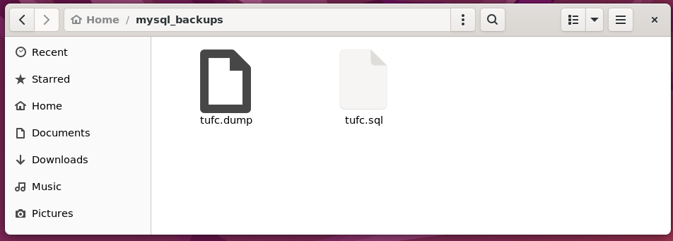

**NOTE:** I’ve created Jira ticket: *XWM14 - Create a 'mysqldump' backup on a network drive*

to do mysqldump network backups.

In the meantime, I’ll manually copy the folder ~/mysql_backups to

* the host machine’s backup USB drive *(described next)*
* and the GitHub repository

## Backup the mysqldump for ‘tufc’ on a network share

### Share a Folder on the Network

#### Install samba smbclient

On the computer that will host the shared folder

install **samba smbclient** by running the commands:

sudo apt update

sudo apt install samba smbclient

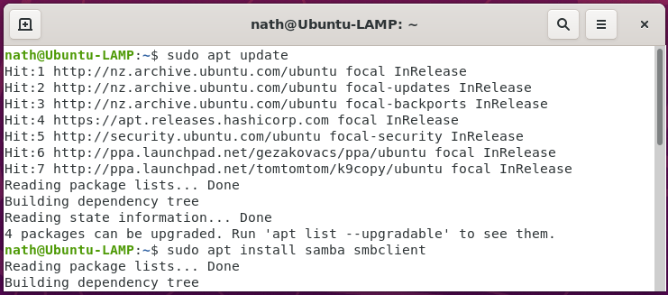

Check the status of samba, using the command

sudo systemctl status smbd

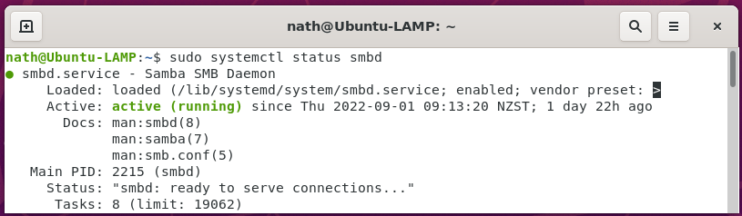

#### Allow samba through the firewall

Use **ufw** to allow samba through the firewall

using the command

sudo ufw allow 'Samba'

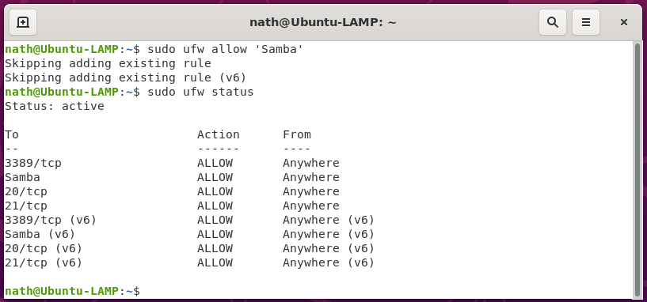

v

Check samba is allowed through the firewall

using the command

sudo ufw status



v

v

*Next, Create the network share folder …*

#### Create the network share folder

Using **Files** create the folder to be shared.

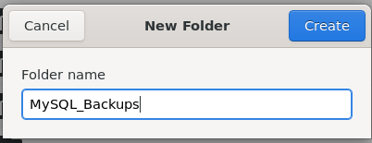 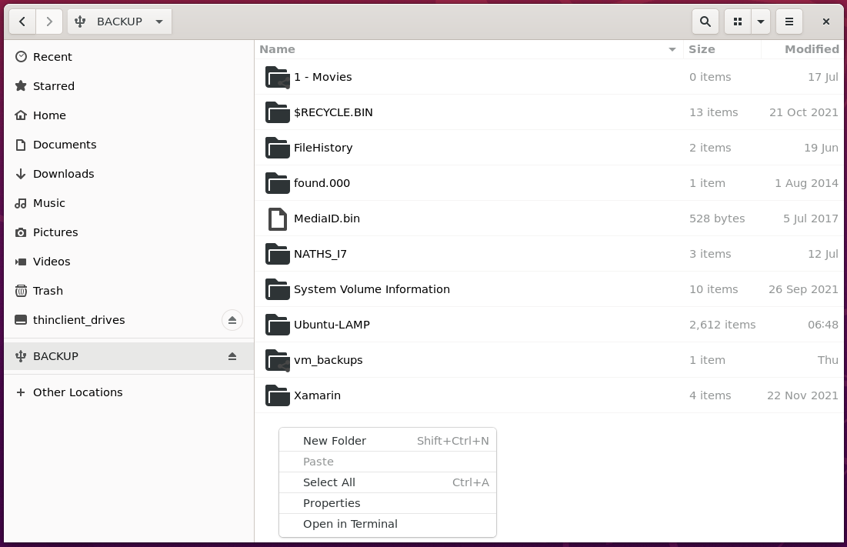

Right click on the folder to be shared

and select **Local Network Share**

Click **Create Share**

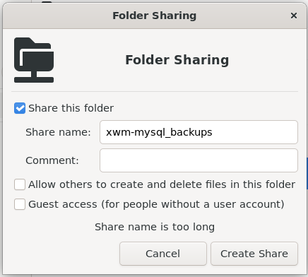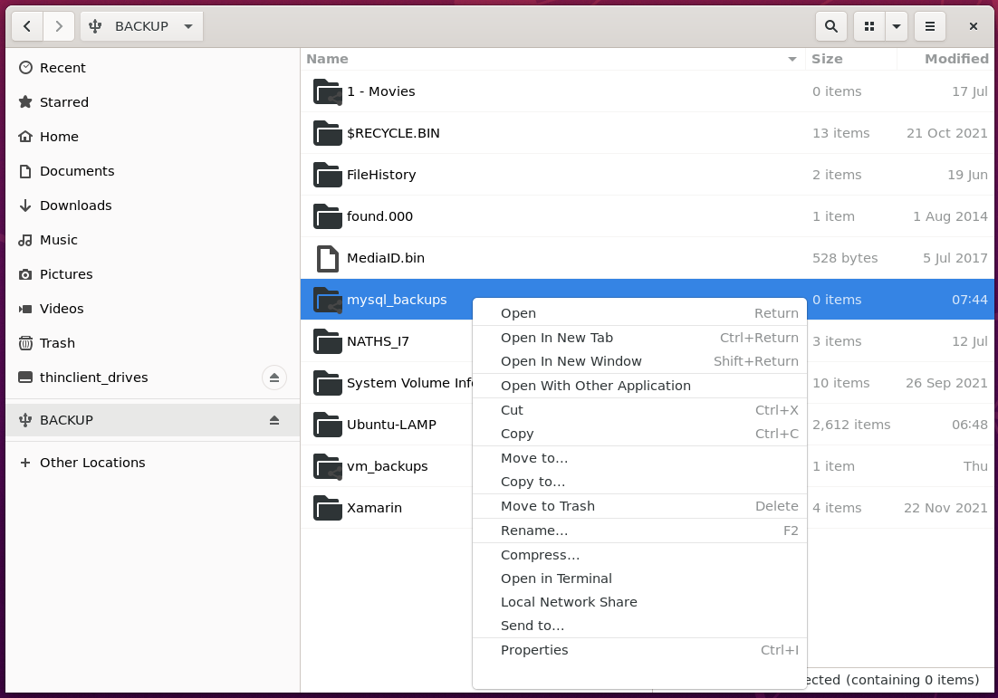

*Next, Accessing the shared folder…*

#### Accessing the shared folder

Open **Files** on the virtual machine **xwm-mysql**

then select **Other Locations > Ubuntu-LAMP**

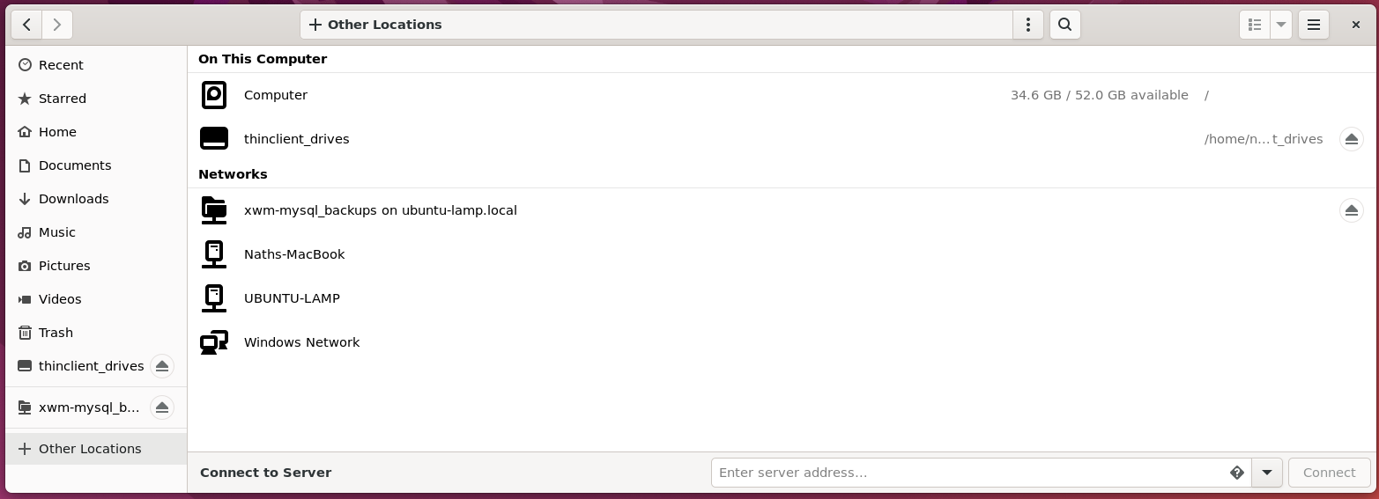

Right click the shared folder and select **Properties**

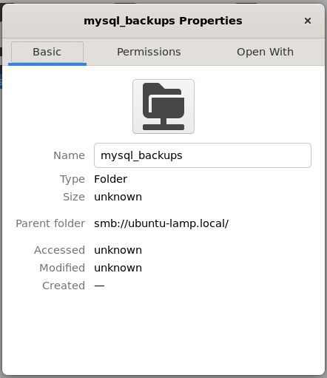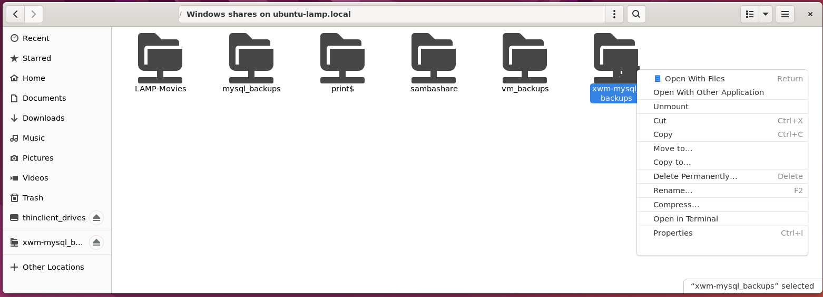

Create the shared path using a combination of

* a server’s **username** *(that has read/write permissions on the shared folder)*
* and the **Parent folder** address
* the folders **Name**

Combined string: **smb://nath@ubuntu-lamp.local/mysql_ backups**

Connect to the shared folder, by selecting **Other Locations**

and entering the combined string: **smb://nath@ubuntu-lamp.local/mysql_backups**

in the text field **Connect to server**

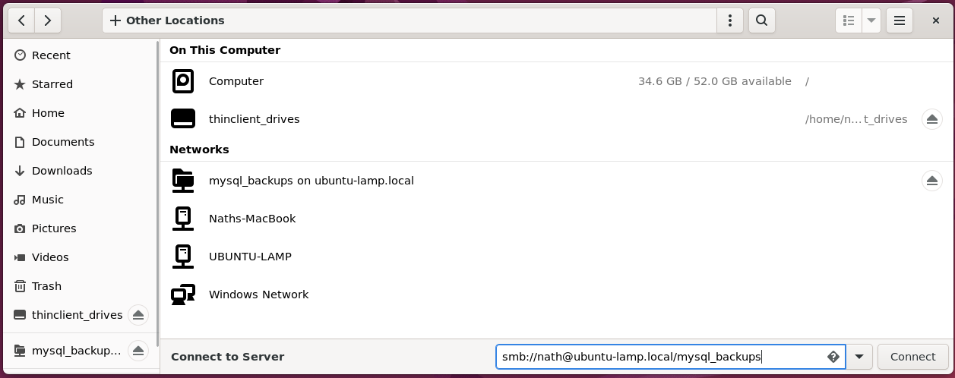

Click **Connect** *(above)*

to open the shared folder.

*Next, Links are automatically created …*

Ubuntu automatically creates a link to the share

in the left panel of **Files**

and on the right, under **Other Locations**

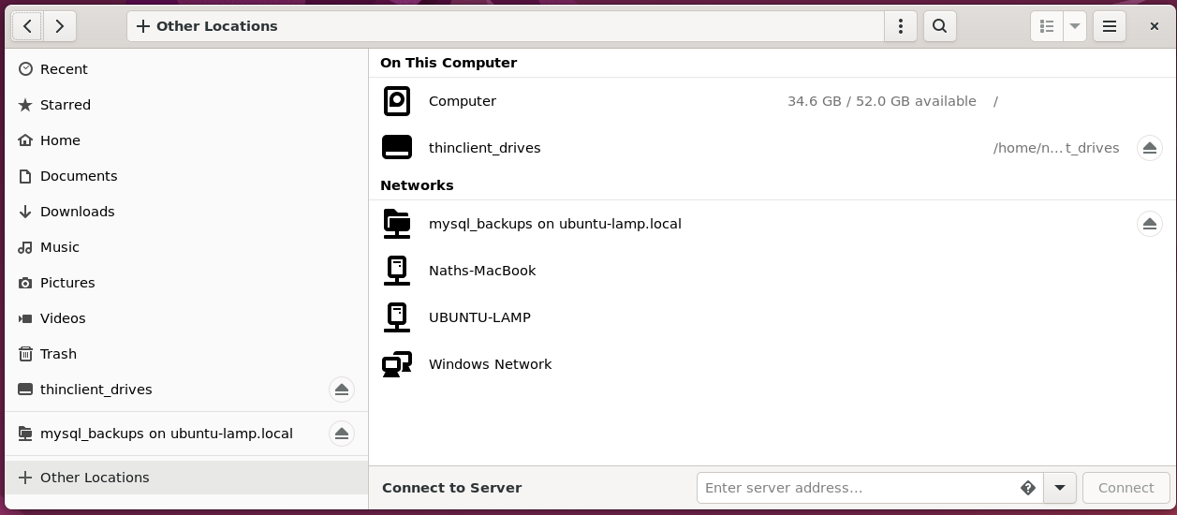

#### Copy the mysqldump folder to the network share

To backup the mysqldump folder to the network share

for the database **tufc**, copy and paste folder:

from: **~/mysql/mysql_backups**

to: **smb://ubuntu-lamp.local/mysql_backups**

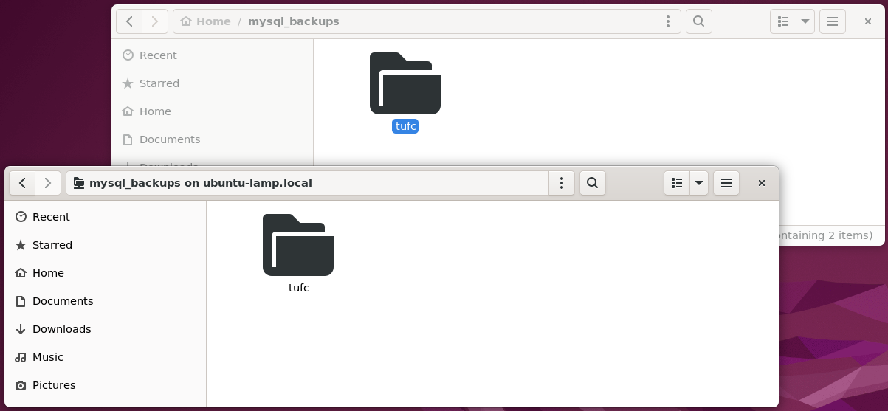

As well as creating backing up the MySQL database tufc

using mysqldump, do a:

* Ubuntu backup
* VirtualBox snapshot

#### Create an Ubuntu (Deja Dup) backup

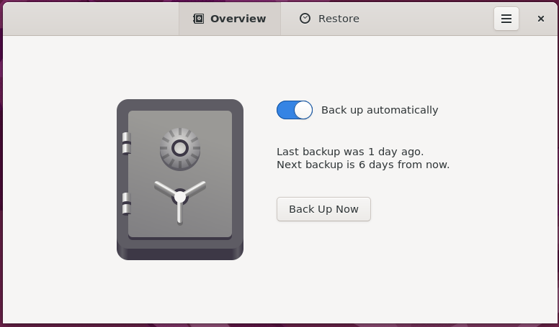

#### Create a VirtualBox snapshot

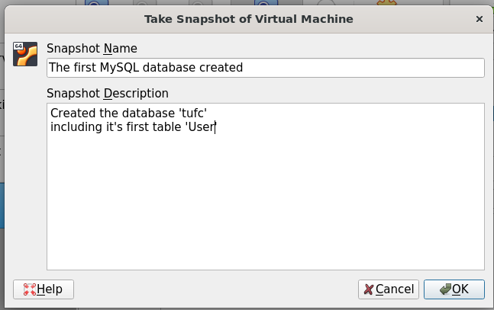

# MySQL remote connection

https://phoenixnap.com/kb/mysql-remote-connection

Both the Xamarin application and webserver

need to connect to the MySQL database tufc

located on the server xwm-mysql

To set up a remote MySQL connection

1. Edit the MySQL configuration file
2. Configure the server’s firewall
3. Connect to remote MySQL server

## 1 -Edit MySQL config file

### Edit mysqld.cnf

To configure the MySQL database for connections from any IP address

the settings bind-address and mysqlx-bind-address

need to be commented out in file mysqld.cnf

Before making any changes, create a backup of mysqld.cnf

located in /etc/mysql/mysql.conf.d

by running the command

sudo cp mysqld.cnf mys.cnf_backup

#### Example – Create a backup of ‘mysqld.cnf’

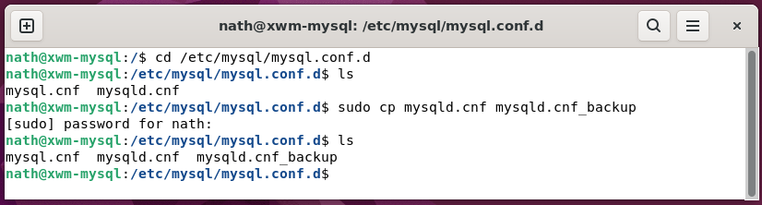

To edit the file mysqld.cnf using nano

run the command

sudo nano mysqld.cnf

#### Example – Open ‘mysqld.cnf’ for editing

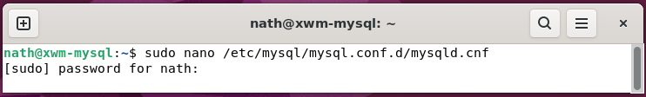

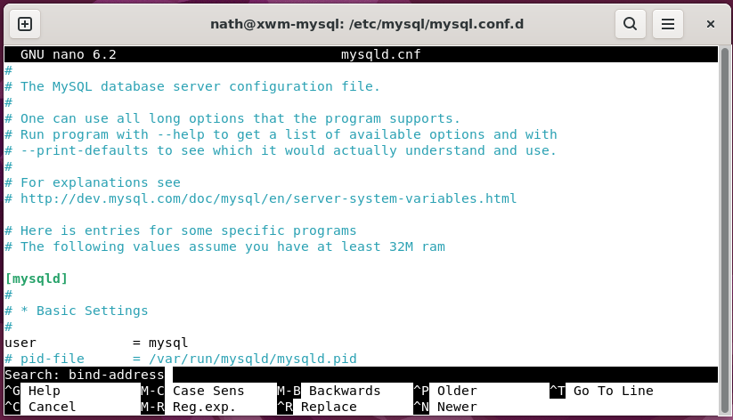

Use the nano Where Is function *(Ctrl+W)*

to find bind-address *(shown above)*

*Next, Comment out the bind-address settings …*

Use the pound symbol to comment out the lines:

bind-address = 127.0.0.1

mysqlx-bind-address = 127.0.0.1

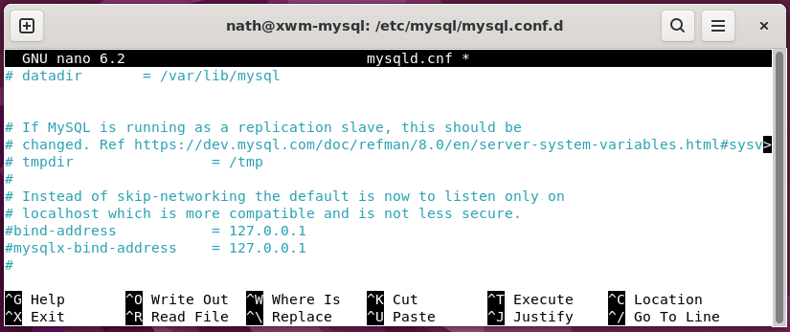

With these lines are commented out

MySQL will allow queries from any IP address.

Save the file mysqld.cnf *(Ctrl+S)*

and exit *(Ctrl+X)*

For changes to take effect

the MySQL service needs to be restarted

using the command

sudo systemctl restart mysql

#### Example – Restart mysql

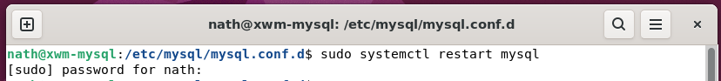

*Next, Allow mysql through the firewall …*

## Allow MySQL through the firewall

To allow MySQL data through the firewall

run the following commands:

sudo ufw allow out 3306/tcp

sudo ufw allow in 3306/tcp

#### Example – Allow MySQL through the firewall

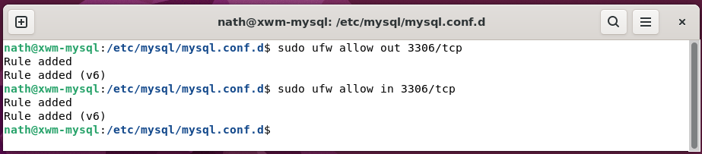

To check the rules have been applied

run the command

sudo ufw status

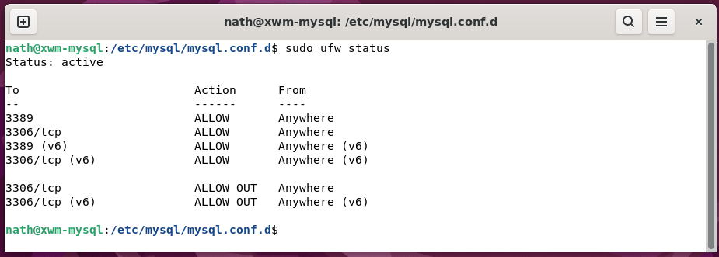

*Next, Grant remote access to a MySQL database …*

## Remotely connect to MySQL on xwm-mysql

From another computer *(in my case the server ubuntu-mysql)*

that has the application mysql installed

connect to the server xwm-mysql

by running the command

mysql -h ***host*** -u ***accountname*** -p

Key:

-h: *the MySQL host server*

-u: *the MySQL user account*

-p: *requires the user password to be entered*

#### Example – Connect to MySQL on the server ‘xwm-mysql’ okay

mysql -h xwm-mysql -u admin -p

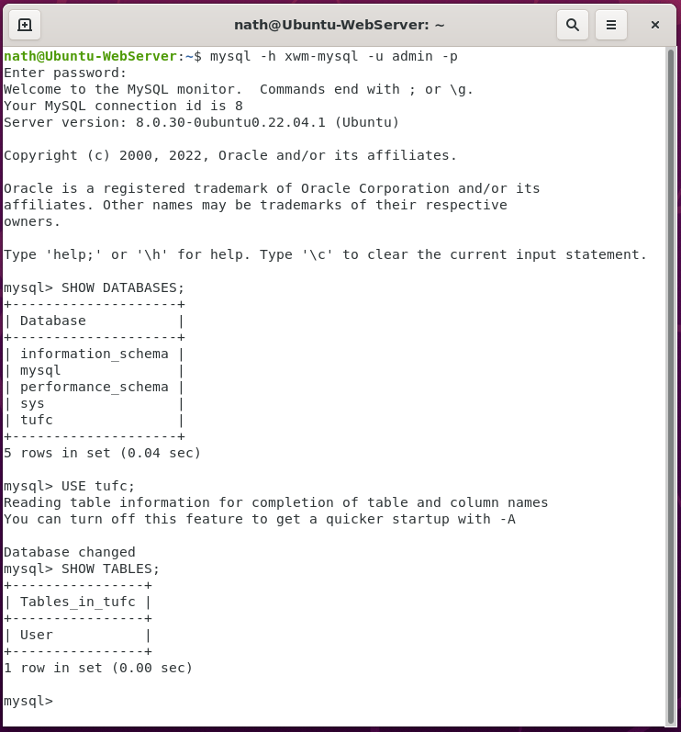

The remote connection is accepted.

The database tufc

and table User

can be accessed from a remote computer.

Now is a good time to do an Ubuntu backup

and VirtualBox snapshot for the server xwm-mysql

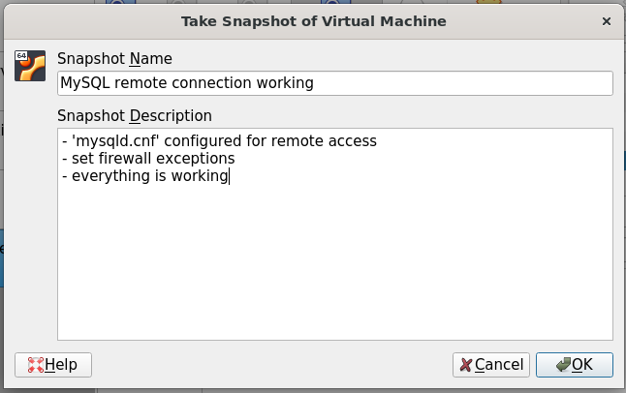

### A few quick SQL tests - *CRUD*

Everything appears to be working correctly on the MySQL server.

I’ll run a few quick SQL commands

to make sure I can manipulate data in the table User

contained in the database tufc

To do this I’ll remote in to the server xwm-mysql

and run data processing CRUD commands:

* create INSERT
* read SELECT
* update UPDATE
* delete DELETE

### Connect to MySQL server

mysql -h xwm-mysql -u admin -p

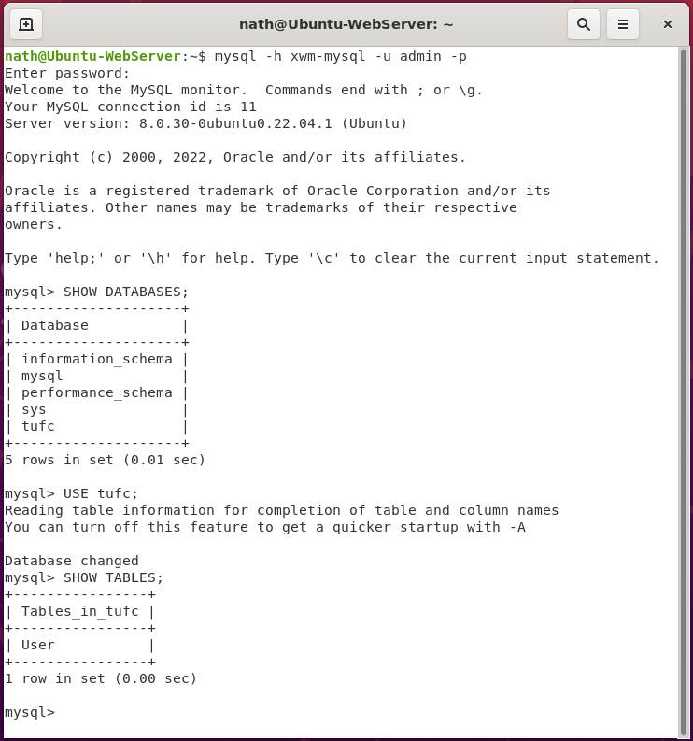

### SELECT

SELECT column1, column2, ...  
FROM table_name;

***or*** SELECT *

FROM User;

#### Example – Select all columns on the ‘User’ table

SELECT userID, firstname, lastname, email

FROM User;

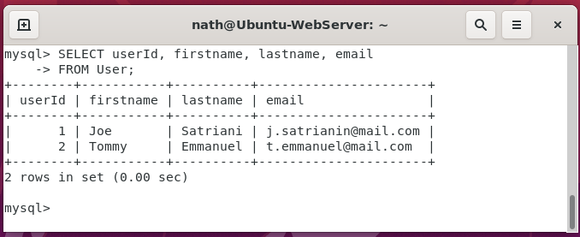

*Next, INSERT …*

### INSERT

INSERT INTO table_name (column1, column2, column3, ...)

VALUES (value1, value2, value3, ...);

#### Example – Insert ‘Tommy Emmanuel’, in to the table ‘User’

INSERT INTO User(firstname, lastname, email, createDate)

VALUES(‘Tommy’, ‘Emmanuel’, ‘t.emmanuel@mail.com’, NOW());

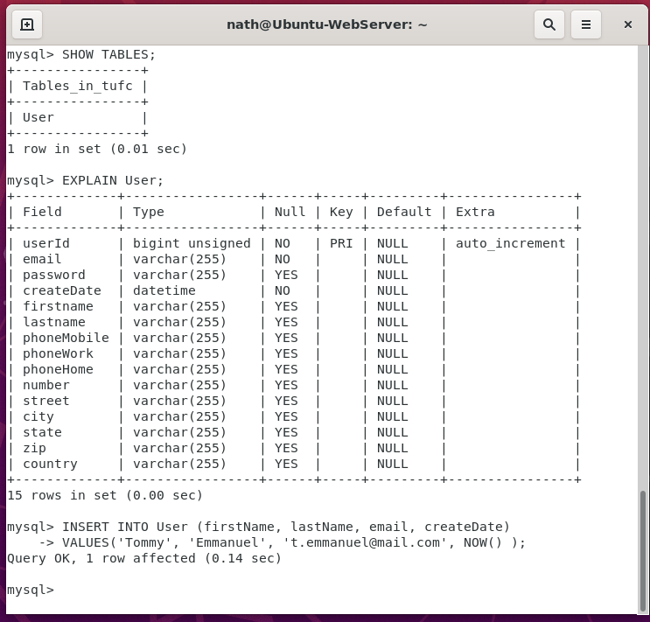

### UPDATE

UPDATE table_name

SET column1 = value1, column2 = value2, ...

WHERE condition;

#### Example – Update ‘Satriani’ in the table ‘User’

UPDATE User

SET email = ‘j.satriani@mail.com’

WHERE userId = 1;

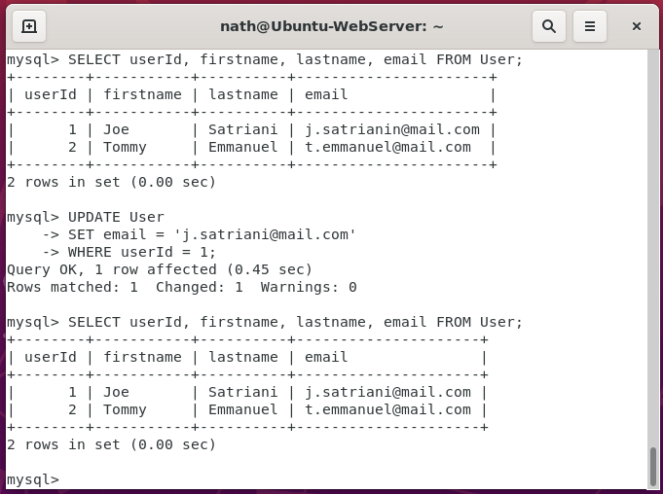

*Next, DELETE …*

### DELETE

DELETE FROM table_name

WHERE condition;

#### Example – Delete a row, from the table ‘User’

DELETE FROM User

WHERE userID = 3;

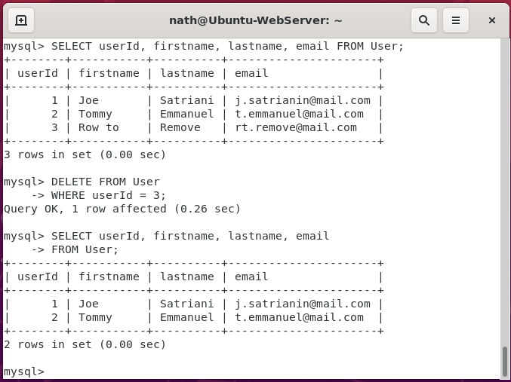

## ‘xwm-mysql’ is working

The initial configuration of the MySQL server xwm-mysql

is working correctly.

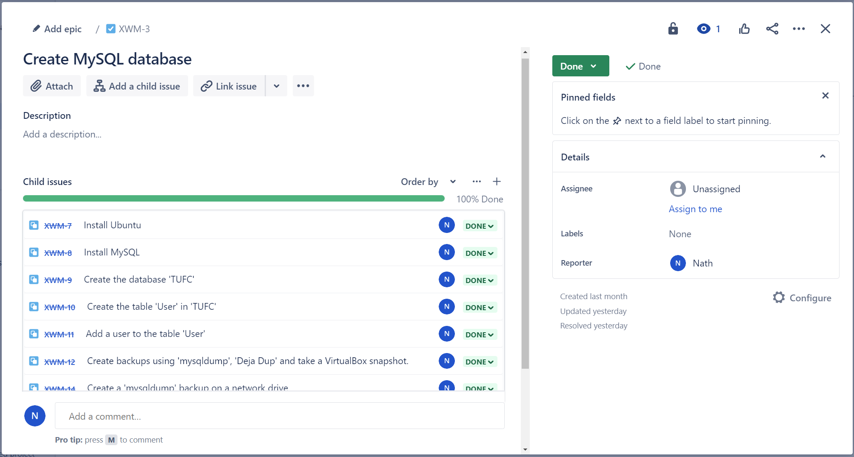

I can now move on the Xamarin and webserver projects.